**Mastering Apple Interview Process: Full Guide for Data Scientist**

[[Nathan Rosidi](https://nathanrosidi.medium.com/?source=post_page-----f8fb2e0d76ad--------------------------------)](https://nathanrosidi.medium.com/?source=post_page-----f8fb2e0d76ad--------------------------------)

[Nathan Rosidi](https://nathanrosidi.medium.com/?source=post_page-----f8fb2e0d76ad--------------------------------)

·

[Follow](https://medium.com/m/signin?actionUrl=https%3A%2F%2Fmedium.com%2F_%2Fsubscribe%2Fuser%2Fab636cbf3611&operation=register&redirect=https%3A%2F%2Fnathanrosidi.medium.com%2Fmastering-apple-interview-process-full-guide-for-data-scientist-f8fb2e0d76ad&user=Nathan+Rosidi&userId=ab636cbf3611&source=post_page-ab636cbf3611----f8fb2e0d76ad---------------------post_header-----------)

10 min read

·

Aug 11, 2023

384

4

*Unlock the Secrets of the FAANG Interview Process: From Resume Evaluation to Offer Negotiation*

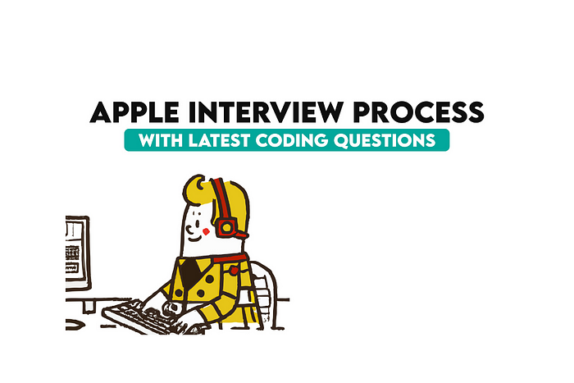

Image by author

Interviews can be overwhelming, but not if you prepare enough.

But how would you know that you are well prepared? Of course, by solving actual interview questions, which might be repeated in your interview. There are numerous interview questions on the platform, and I will introduce you to them exactly where needed in this article.

Many of these interview questions will be from FAANG companies.

**Do you know what FAANG is?**

FAANG contains the initials of big tech companies, Facebook, Amazon, Apple, Netflix, and Google.

Working for these tech giants is a dream for many data scientists.

Yet you can see many different articles, courses, and seminars, presented by ex-netflix data scientists, ex-google data scientists, etc.

So even after leaving these companies, you can still reference your previous title.

And the success of these companies is not by luck. They presented good products, created by the best of the best.

But how to be one of them?

**How does the Apple Interview process go?**



Image by author

In the following article, we will explore the Apple interview process by splitting it through stages and also will present to you the source of coding or noncoding questions that will help you along the way.

Now I understand that some of you are data scientists in different fields, while others are eager to learn Data Science. But one thing I am sure, if you did not work for Apple before, you probably are wondering about it.

Before going into the Apple interview process, first, let’s see different areas at Apple that data scientists can work.

**What Are the Areas of Work for Data Scientists at Apple?**

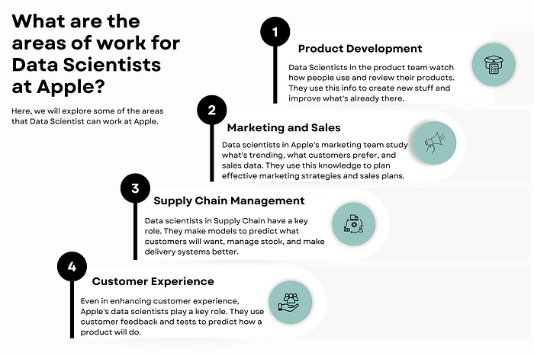

Image by author

If you have data, you likely need a Data Scientist. At Apple, data scientists have many options when it comes to showing their magic.

Here are some places and an explanation of what they do;

* **Product Development:** In the product department, data scientists take a close look at how people use their products and what they say about them, to improve Apple’s products. They share their findings to help create new features and make existing ones even better.
* **Marketing and Sales**: In marketing and sales, Data scientists look at what’s popular in the market, what customers like, and how well things are selling. They use this info to plan good marketing campaigns and sales strategies. Their work can change everything, from where a product fits in the market to special deals offered to customers.
* **Supply Chain Management:** Apple’s supply chain is a global operation. Here Data Scientists play an important role in this process, like doing modeling to forecast demand, manage inventory and improve logistics.
* **Customer Experience:** I feel like I am hearing your question, even in customer experience. And the answer is yes even in customer experience, data scientists have a role. Data Scientists can analyze customer feedback or do A/B testing, to build a model, which predicts product performance.

Each of these areas, like many others, presents unique challenges and opportunities for data scientists to be part of Apple.

**What is the interview process like at Apple?**

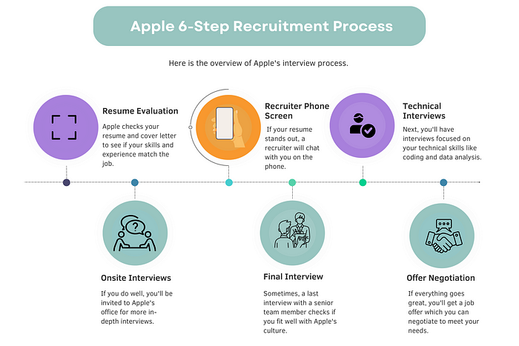

Image by author

Here let’s see how Apple 6-Step Recruitment Process goes. Apple’s interview process is known for its difficulty, but the knowledge is power and here we aim to prepare it by gaining knowledge about it. I did not include the application process, since you might wonder about the process after applying for the job. Here is a general overview of the steps involved:

* **Resume Evaluation:**First, your resume and cover letter will be looked at. At this stage, Apple will check if you have the skills and experience that the job needs. They’re on the lookout for signs of technical skill, problem-solving chops, and evidence of teamwork and innovation.
* **Recruiter Phone Screen:** If your resume catches their eye, you will have a phone chat with a recruiter. This is when you talk about your resume and work experience, and see if you would fit in with Apple’s culture. It’s also a great time for you to ask about the job and the team.
* **Technical Interviews:** Next up are the technical interviews, often over the phone or video. If you’re going for a data scientist role, the questions will be about machine learning, coding, handling data, and stats. These chats help us understand your tech-savvy and problem-solving skills.
* **Onsite Interviews:** If you ace the technical chats, you are in for an onsite visit. Expect a mix of tech, behavior, and situational questions. You might be asked to solve problems or present a case study.
* **Final Interview:**Sometimes, there could be a final interview with a top team member. This chat is all about seeing if you fit with Apple’s culture and values. It’s time for you and Apple to check if this is the right match.
* **Offer Negotiation:** If everything goes smoothly, Apple will make you an offer. Here, you might be able to talk about the terms of your job. Remember to balance between work and life, and chances to grow and learn.

Remember, the Apple interview process can vary depending on the role and team you’re applying to.

**How Long Does the Apple Interview Process Take?**



Image by author

Well, it really depends on the job, the team, and how many interviews there are.

On the whole, you could be looking at a few weeks to a couple of months.

But keep in mind, these are just ballpark figures and can change. It’s always smart to ask your recruiter about the timeline right at the start. This way, you’ll know what to expect and can keep your job hunt neat and tidy.

**What Skills Does Apple Look For in Their Data Scientists?**

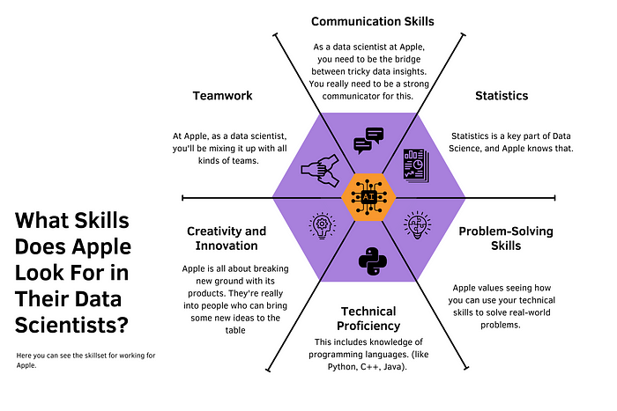

Image by author

Apple seeks a blend of technical and soft skills in its data scientists. Here are some key skills that Apple often looks for:

* **Technical Proficiency:** This includes knowledge of programming languages (like Python, C++, Java). Apple first asks about your choice of programming language.  
  Then it is time to show your skills. They might ask you to find [***Active Users Per Platform***](https://platform.stratascratch.com/coding/2072-active-users-per-platform?code_type=2&utm_source=blog&utm_medium=click&utm_campaign=medium+apple+interview)***,*** to see your data manipulation skills, and if you select your coding language Python.  
  You can do this with the pandas groupby function.  
  Do you want to know more about Python pandas interview questions for Data Science, [here](https://www.stratascratch.com/blog/python-pandas-interview-questions-for-data-science/?utm_source=blog&utm_medium=click&utm_campaign=medium+apple+interview) you can find them.
* **Problem-Solving Skills**: Apple values seeing how you can use your technical skills to solve real-world problems. That’s why — find from here, they ask these questions, of course, these questions include knowledge about Data Science too.
* **Statistics:** Statistics is a key part of Data Science, and Apple knows that. You should test your skills in statistics. Let’s say, you build a machine learning model and your evaluation metric is the f1 score.  
  — But first, what is the f1 score?  
  [Here](https://platform.stratascratch.com/technical/2412-calculating-f1-score?utm_source=blog&utm_medium=click&utm_campaign=medium+apple+interview) you can find an answer to that question before the interview.  
  And also be aware that this question is one of the favorite questions of 3 FAANG companies, Amazon Google, and Apple.
* **Communication Skills**: As a data scientist at Apple, you need to be the bridge between tricky data insights. You really need to be a strong communicator for this.  
  Your job? Making sure you can break down your findings into clear, easy-to-grasp nuggets, whether you’re writing it down or chatting about it because data science essentially includes communication through data.
* **Teamwork**: At Apple, teamwork makes the dream work. As a data scientist, you’ll be mixing it up with all kinds of teams. So, being a team player isn’t just nice, it’s a must-have. Make sure you can show times when you’ve really shone in a team setting.
* **Creativity and Innovation**: Apple is all about breaking new ground with its products. They’re really into people who can bring some new ideas to the table. You’ll need to show how you’ve let your creativity fly and brought some cool new ideas into your work.

These skills are seeking to be a data scientist at Apple. By demonstrating these skills in your application and interview, you can show that you’re a strong fit for the role.

**How to Best Prepare for Your Apple Interview?**

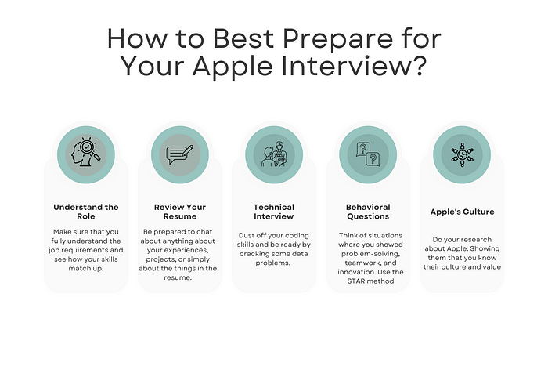

Image by author

Wondering how to ace your Apple interview? Preparation is everything. Here are some tips:

* **Understand the Role:** Make sure that you fully understand the job requirements and see how your skills match up. This will help you tailor your application and answers to show you’re the perfect fit.
* **Review Your Resume**: Be prepared to chat about anything about your experiences, projects, or simply about the things in the resume. Spotlight experiences that show you’ve got what Apple is looking for. This could be projects where you showed your tech skills or times you rocked at problem-solving or teaming up.
* **Technical Interview:** Dust off your coding skills and be ready by cracking some data problems. Sites like [StrataScratch](https://stratascratch.com/?utm_source=blog&utm_medium=click&utm_campaign=medium+apple+interview" \t "_blank) and[Leetcode](https://leetcode.com/) are great for practice. And don’t forget to brush up on machine learning and stats. We’ll talk more about this in the next section.
* **Behavioral Questions**: Think of situations where you showed problem-solving, teamwork, and innovation. Use the STAR method (Situation, Task, Action, Result) to build your responses. This will help you give a clear answer.
* **Apple’s Culture:** Do your research about Apple. Showing them that you know their culture and value, will demonstrate that you would be a great fit with the company. And do this in an exciting way and try to be creative, don’t present them with “Google searched” examples, be original.

Follow these tips and you’ll walk into your Apple interview prepared and full of confidence.

**How can you prepare for a Data Science technical interview at Apple?**

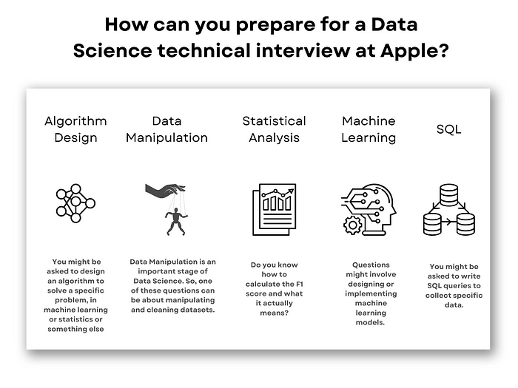

Image by author

Apple’s data science interviews often include coding challenges. Here are some examples of the types of questions you might encounter:

* **Algorithm Design**: You might be asked to design an algorithm to solve a specific problem, in machine learning or statistics or something else. For example, “Design an algorithm to predict customer churn” This tests your understanding of algorithms and your problem-solving skills. And here you can find a data project [here](https://platform.stratascratch.com/data-projects/customer-churn-prediction?utm_source=blog&utm_medium=click&utm_campaign=medium+apple+interview), that will help you grasp concepts of Customer Churn Prediction.
* **Data Manipulation**: Data Manipulation is an important stage of Data Science. So, one of these questions can be about manipulating and cleaning datasets. For example, “Count the number of user events performed by MacBookPro users”. This is an actual question, that has been asked by Apple, you can find more information [here](https://platform.stratascratch.com/coding/9653-count-the-number-of-user-events-performed-by-macbookpro-users?code_type=2&utm_source=blog&utm_medium=click&utm_campaign=medium+apple+interview).  
  This tests your coding skills and your understanding of data manipulation techniques.
* **Statistical Analysis:** You could be asked about the Statistic terms. Do you know how to calculate the F1 score and what it actually means? This question is actually asked by 3 different FAANG companies, Amazon, Apple, and Google. [Here](https://platform.stratascratch.com/technical/2412-calculating-f1-score?utm_source=blog&utm_medium=click&utm_campaign=medium+apple+interview) you can find more about this question.
* **Machine Learning:** Questions might involve designing or implementing machine learning models. For example, “How is the value k selected in k-means clustering? [Here](https://platform.stratascratch.com/technical/2347-selecting-k?utm_source=blog&utm_medium=click&utm_campaign=medium+apple+interview) you can find more about this information.  
  This tests your understanding of machine learning algorithms and your ability to apply them to practical problems
* **SQL**: You might be asked to write SQL queries to collect specific data. For example “How many accounts have performed a login in the year 2016?”. And guess what, this question has been asked by both Apple and Google. You can try solving this question, from [here](https://platform.stratascratch.com/coding/9649-count-the-number-of-accounts-used-for-logins-in-2016?code_type=1&utm_source=blog&utm_medium=click&utm_campaign=medium+apple+interview).  
  This tests your understanding of machine learning algorithms and your ability to apply them to practical problems

Remember, the key to acing these questions is practice. Use online resources like [Apple Data Scientist Interview Questions](https://www.stratascratch.com/blog/apple-data-scientist-interview-questions/?utm_source=blog&utm_medium=click&utm_campaign=medium+apple+interview) to find more practice questions and solutions.

**Conclusion**

The Apple interview is tough but fair. It tests not just your tech skills, but also how you solve problems, communicate, and fit in with the Apple culture.

Focus on the process and research what Apple is after, and you’ll be well on your way to acing it.

Remember, the name of the game is preparation.

Work on your coding, go over your resume, get ready for behavioral questions, and get familiar with Apple’s culture.

With solid preparation, you will nail your Apple interview and be one step closer to your dream data science job.

Visit our [platform](https://platform.stratascratch.com/coding?utm_source=blog&utm_medium=click&utm_campaign=medium+apple+interview), discover the coding and non coding questions, hone your skills by cracking them. It will help you prepare for data science interviews at big-name companies like FAANG.In the platform, there are too many interview questions and answers exist, so you can practice coding, learn from others, and build up your interview confidence.

I hope this rundown gives you a clear idea of the Apple interview process, and I hope you get that position you want.

Best of luck with your preparation and interviews!

**FAQ**

**How many rounds of interview for Apple?**

Apple’s interview process typically consists of 4–5 rounds.

**How long does Apple interview process take?**

​​There is no standard here, but the entire interview process at Apple can take 4–8 weeks.

**What are the hiring processes for Apple?**

Apple’s hiring process includes resume screening, phone screening, technical interviews, on site interviews(this might be changing) and a final round with the hiring manager.

*Originally published at*[*https://www.stratascratch.com*](https://www.stratascratch.com/blog/mastering-apple-interview-process-full-guide-for-data-scientist/?utm_source=blog&utm_medium=click&utm_campaign=medium+apple+interview)*.*